Segment-4
Data Flow Diagram(DFD)

A Data Flow Diagram (DFD) is a graphical representation used in system analysis to show how data moves through a system—from input to processing to output. It helps to understand how information flows and how different parts of a system interact.

A Data Flow Diagram (DFD) is a graphical tool used to represent the flow of data within a system, showing how data is processed, stored, and transferred between different components.

Key Components of DFD
- Process (Circle / Bubble)
  - Represents activities that transform data. A data transformer (changes input to output)
  - Example: Calculate Salary ,compute taxes, determine area, format report, display graph
Process

- Data Flow (Arrow)
  - Shows the movement of data between components. Data flows through a system, beginning as input and transformed into output.
  - Example: Employee Details → Process
Data flow

- Data Store (Open Rectangle / Two Parallel Lines)
  - Represents storage of data.
  - Example: Database, File
Data store

- External Entity (Rectangle)
  - Represents outside systems or users interacting with the system.
  - A producer or consumer of data
  - Examples: a person, a device, a sensor
External Entity

DFD Rules and Tips
- Each process should have at least one input and an output.
- Each data store should have at least one data flow in and one data flow out.
- Data stored in a system must go through a process.
- All processes in a DFD go to another process or a data store.
DFD levels and layers:
- A data flow diagram can dive into progressively more detail by using levels and layers, zeroing in on a particular piece.
- DFD levels are numbered 0, 1 or 2, and occasionally go to even Level 3 or beyond
DFD 0
- DFD Level 0 is also called a Context Diagram. It’s a basic overview of the whole system or process being analyzed or modeled.
- It’s designed to be an at-a-glance view, showing the system as a single high-level process, with its relationship to external entities.
- It should be easily understood by a wide audience, including stakeholders, business analysts, data analysts and developers.
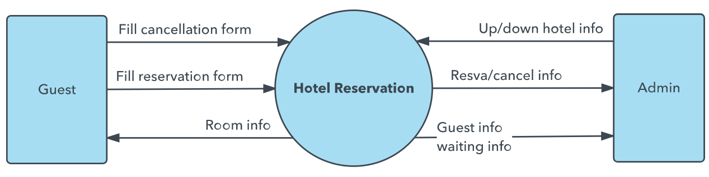
DFD-1
- DFD Level 1 provides a more detailed breakout of pieces of the Context Level Diagram.
- You will highlight the main functions carried out by the system, as you break down the high-level process of the Context Diagram into its sub-processes
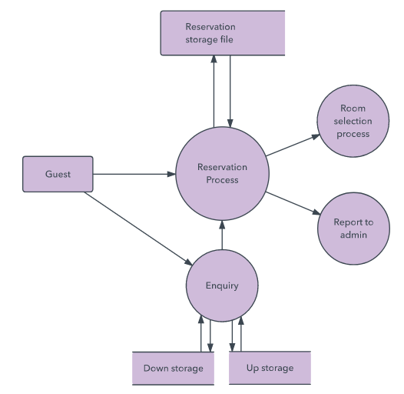
DFD-2
- DFD Level 2 then goes one step deeper into parts of Level 1.
- It may require more text to reach the necessary level of detail about the system’s functioning.

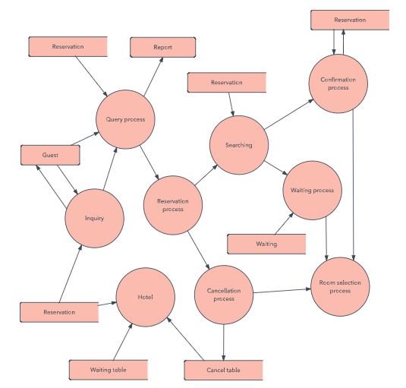
DFD 3, 4
- Progression to Levels 3, 4 and beyond is possible, but going beyond Level 3 is uncommon.
- Doing so can create complexity that makes it difficult to communicate, compare or model effectively.
Sample Question:
- A university library management system is being developed to handle the borrowing and returning of books. Students can search for available books, borrow them using their student ID, and return them before the due date. The librarian manages the book inventory and student records. When a student borrows a book, the system records the transaction and updates the availability status of the book. If a book is returned late, a fine is calculated by the system. The system generates monthly reports for the librarian.
Tasks:
i) Draw the Level 0 Data Flow Diagram (Context Diagram) for the system.
ii) Draw the Level 1 Data Flow Diagram, breaking down the context diagram into at least three sub-processes, such as:
- Book Search and Borrowing
- Book Return and Fine Calculation
- Report Generation
- “EduPortal” is one of the most widely used online learning platforms in the country. The system has the following characteristics:
- Students can create a personal profile with required credentials such as name, email, and password to access the platform.
ii. Students can browse available courses, enroll in selected courses, and track their progress through their dashboards.
iii. Instructors can upload course materials, schedule assignments, and manage course-related activities and view student submissions.
- Both students and instructors must authenticate themselves before accessing any services. Based on the above scenario, let’s identify:
- Find all the external entities
b) Design Context Diagram or Level-0 Diagram
c) Design Level-1 Diagram using balancing and leveling techniques
Process Specification
- Once a DFD is obtained the next step is to precisely specify the process
- Structured English, Decision tables and Decision Trees are used to describe process.
- Decision Trees are used when the process is logically complex involving large number of conditions and alternate solutions
- Decision Table are used when conditions to be tested must follow a strict time sequence.
Decision Trees
A Decision Tree is a diagram that represents decision-making logic in a tree-like structure.
It shows different conditions and the resulting actions.
Decision tree are used to model complicated logic. They can make it easy to see that all possible combinations of conditions have been considered and when conditions are not met, it is easy to see.
- Nodes → Decisions (conditions)
- Branches → Possible outcomes (Yes/No, True/False)
- Leaves → Final actions/results

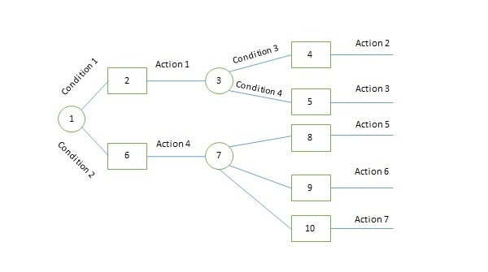
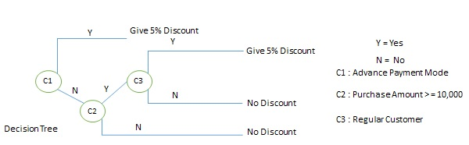
Decision Table
A Decision Table is a structured tool used in system analysis to represent complex decision logic in a tabular form. It shows all possible combinations of conditions and the corresponding actions

Components of a Decision Table
- Conditions (Inputs)
  - The different situations or criteria.
  - Example: Is book returned late?
- Condition Alternatives
  - Possible values of each condition (Yes/No, True/False).
- Actions (Outputs)
  - The result or operation to be performed.
  - Example: Calculate fine
- Rules (Columns)
  - Each column represents a unique combination of conditions and corresponding actions.
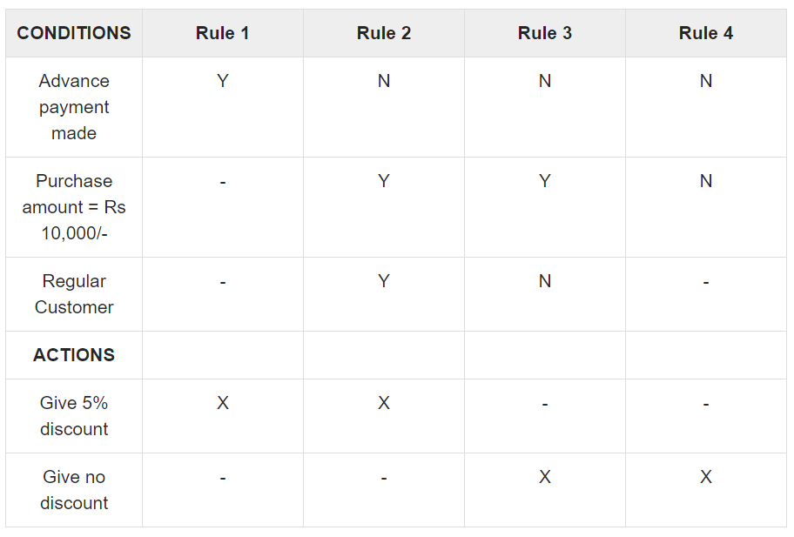

Structured English
- Structured English is similar to a programming language such as Pascal
- It does not have strict syntax rules as programming language
- Intention is to give precise description of a process
- The structured English description should be understandable to the user
Example: Structured English

if customer pays advance then
Give 5% Discount else
if purchase amount >=10,000 then
if the customer is a regular customer
then Give 5% Discount else No Discount
end if
else No Discount end if
end if

When To Use Structured English, Decision Tables and Decision Trees
- Use Structured English if there are many loops and actions are complex
- Use Decision tables when there are a large number of conditions to check and logic is complex
- Use Decision trees when sequencing of conditions is important and if there are not many conditions to be tested

Draw a decision tree and decision table for the following text.
A university has the following grade system.
If the obtained mark in any subject is between 0-39, it implies F;
If the obtained mark in any subject is between 40-49, it implies C;
If the obtained mark in any subject is between 50-59, it implies B;
If the obtained mark in any subject is between 60-69, it implies A;
If the obtained mark in any subject is between 69 and above, it implies A+;

However, if the present of any student is less than 60% of total class then he/she will be awarded grade F, irrespective of the mark that he obtained.
